**SQL - Supply Chain Case Study**

“Richard’s Supply” is a company which deals with different food products. The

company is associated with a pool of suppliers. Every Supplier supplies

different types of food products to Richard’s supply. This company also receives

orders for food products from various customers. Each order may have multiple

products mentioned along with the quantity. The company is maintaining the

database for 2 years.

**Refer to the following Entity-Relationship diagram of the database**

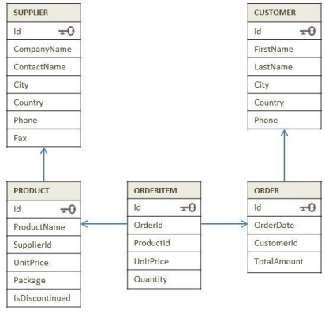

**Instruction to create a supply chain database:**

**Section A: Level 1 Questions**

1. Read the data from all the tables
2. Find the country-wise count of customers.
3. Display the products that are not discontinued.
4. Display the list of companies along with the product name that they are supplying.
5. Display customer information about who stays in 'Mexico'

**Additional: Level 1 questions**

1. Display the costliest item that is ordered by the customer.
2. Display supplier ID who owns the highest number of products.
3. Display month-wise and year-wise counts of the orders placed.
4. Which country has the maximum number of suppliers?
5. Which customers did not place any orders?

**Section B: Level 2 Questions:**

1. Arrange the Product ID and Name based on the high demand by the customer.
2. Display the total number of orders delivered every year
3. Calculate year-wise total revenue.
4. Display the customer details whose order amount is maximum including his past orders.
5. Display the total amount ordered by each customer from high to low.

**Additional Level 2 Questions:**

The sales and marketing department of this company wants to find out how frequently customers do business with them. (Answer Q 6 for the same)

1. Approach - List the current and previous order dates for each customer.
2. Find out the top 3 suppliers in terms of revenue generated by their products.
3. Display the latest order date (should not be the same as the first order date) of all the customers with customer details.
4. Display the product name and supplier name for each order

**Section C: Level 3 Questions:**

1. Fetch the customer details who ordered more than 10 products in a single order.
2. Display all the product details with the ordered quantity size as 1.
3. Display the companies that supply products whose cost is above 100.
4. Create a combined list to display customers and supplier lists as per the below format.

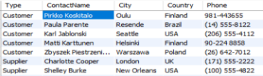

1. Display the customer list who belongs to the same city and country arranged country-wise

**Section D: Level 4 Questions:**

1. The company sells the products at different discount rates. Refer actual product price in the product table and the selling price in the order item table. Write a query to find out the total amount saved in each order then display the orders from highest to lowest amount saved.
2. Mr. Kavin wants to become a supplier. He got the database of "Richard's Supply" for reference. Help him to pick:
   1. List a few products that he should choose based on demand.
   2. Who will be the competitors for him for the products suggested in the above questions?
3. Create a combined list to display customers' and suppliers' details considering the following criteria
   1. Both customer and supplier belong to the same country
   2. Customers who do not have a supplier in their country
   3. A supplier who does not have customers in their country
4. Find out for which products, the UK is dependent on other countries for the supply. List the countries which are supplying these products in the same list.

**Note:** The questions under additional comments in sections should be solved by yourself. If you need any sort of help from the faculty in solving those questions, please seek faculty help after the faculty solves the Level 3 and Level 4 questions.